**Changes for Monitoring Treatment**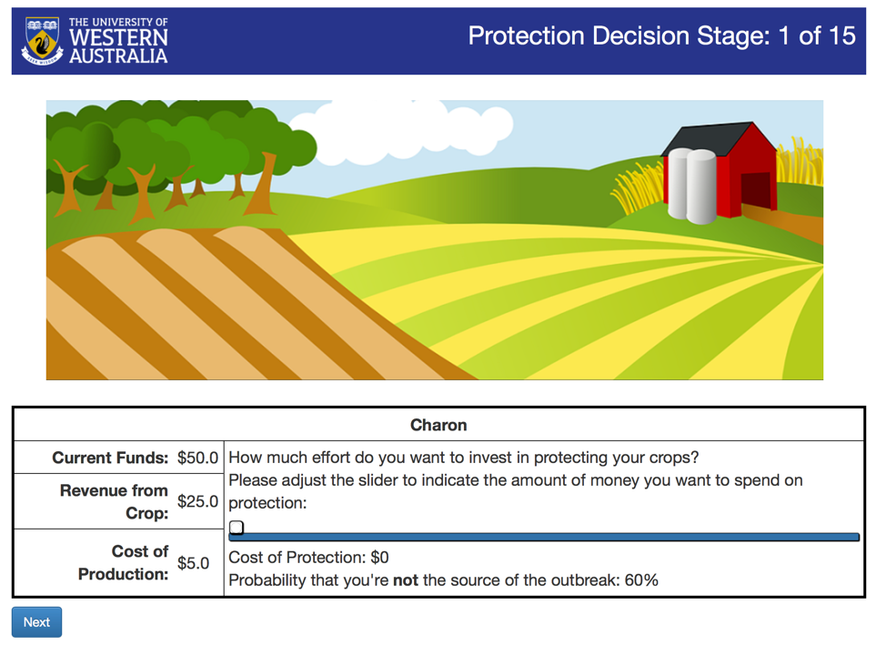

In the final sentence, please change “you’re” to “you are”.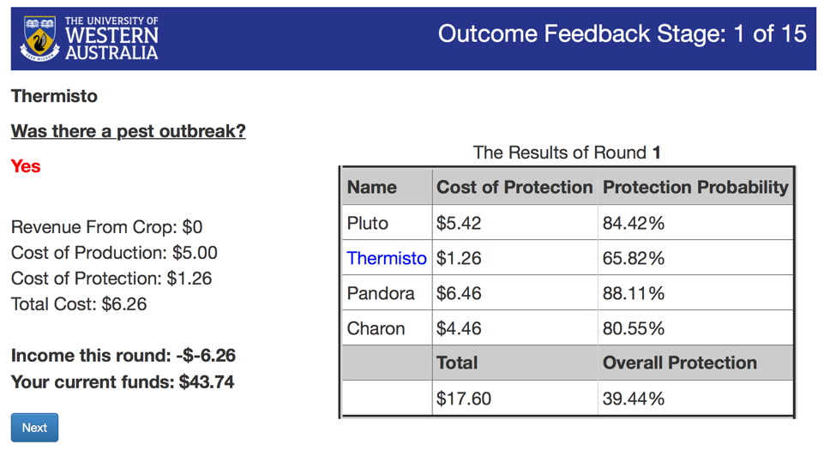

Change “The Results of Round 1” to “Round 1 Contributions”.

Please change “Cost of Protection” in column 4 to simply “Protection”.

**Comment**

As in other versions of the program, “Income this round” includes a double negative.